Project Design Phase
Solution Architecture

Date | 30 September 2026
Team ID | SWTID-2026-9545
Project Name | Import Data using Transform Maps (Spreadsheet) – ServiceNow
Maximum Marks | 4 Marks

Solution Architecture:
Solution architecture bridges the gap between business problems and technology solutions. Its goals are to:
- Find the best tech solution to solve the existing business problem.
- Describe the structure, characteristics and behaviour of the solution to stakeholders.
- Define features, development phases and solution requirements.
- Provide specifications according to which the solution is defined, managed and delivered.
Solution Architecture Diagram:
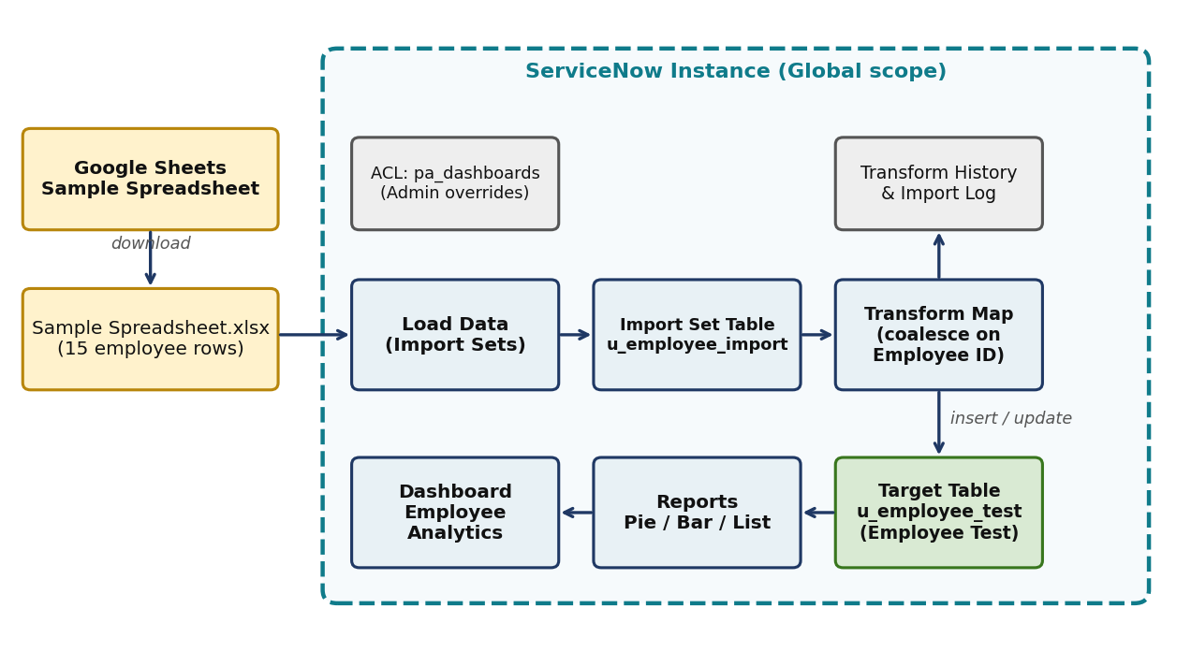
Figure 1: Architecture and data flow of the employee import solution
Architecture description:
- An Excel file is prepared in Google Sheets and downloaded as Sample Spreadsheet.xlsx.
- Load Data reads sheet 1 (header row 1) and stages rows in the Import Set table u_employee_import.
- A Transform Map (Sample Spreadsheet Import) maps five source fields to u_employee_test.
- Coalesce on u_employee_id decides whether each row is inserted, updated or ignored.
- Reports (Pie, Bar, List) read from u_employee_test and are combined on the Employee Analytics Dashboard.
- Transform History and the Import Log record totals, inserts, updates, ignored rows and errors.

Source field (Import Set) | Target field (Employee Test) | Coalesce
u_employee_id | u_employee_id | true
u_name | u_employee_name | false
u_email | u_email | false
u_department | u_department | false
u_location | u_location | false

